**Title**:

Camera-Based Virtual Fitness Trainer

**Introduction**:

This Python project utilizes MediaPipe’s body-tracking model to track and recognize exercise gestures based on heuristic, angles, and coordinate.

**Installation**:

The following libraries must be installed for this project:

* cv2
* mediapipe
* NumPy
* Tkinter

You can install these libraries by the following:

pip install opencv-python

pip install mediapipe

pip install numpy

**Usage**:

To use this project, you can run the following command:

python bodygui2.py

After running the program, you will be presented with a GUI that shows various workouts that can be performed.

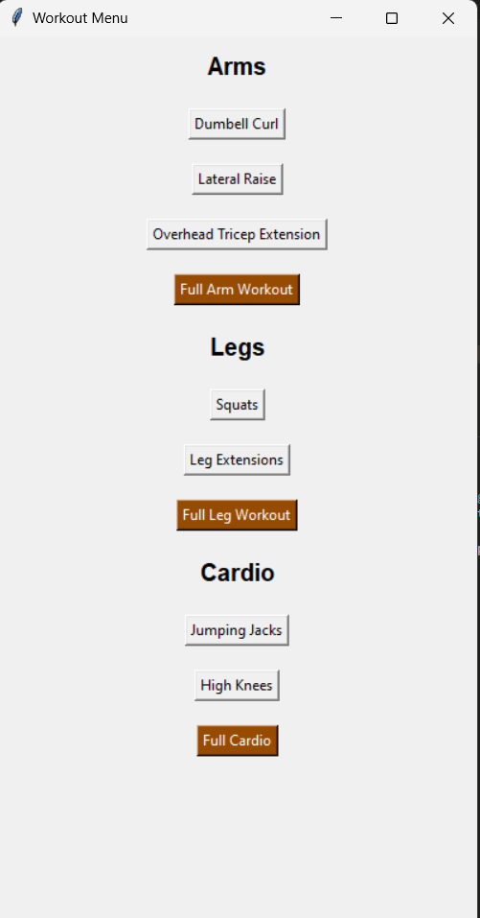

This program is designed to track how many reps of a chosen workout you have done. The following pictures will show you how to perform each workout.

**Arms**

Dumbbell Curl

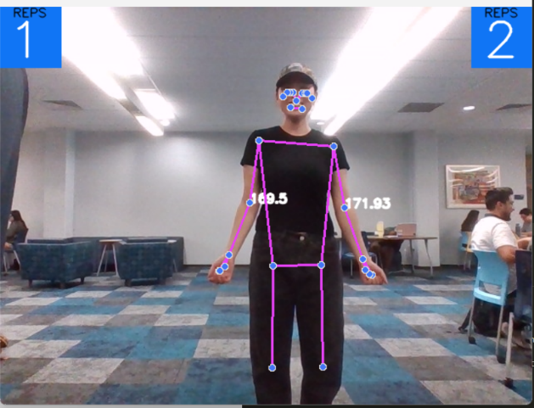 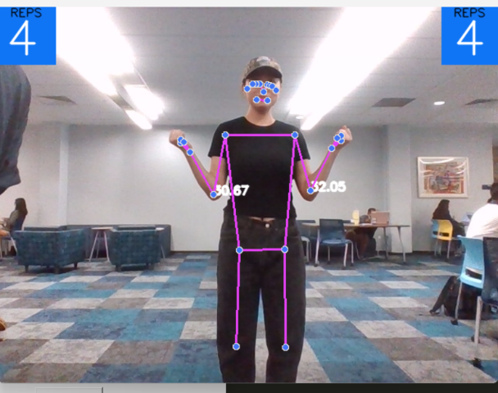

Lateral Raise

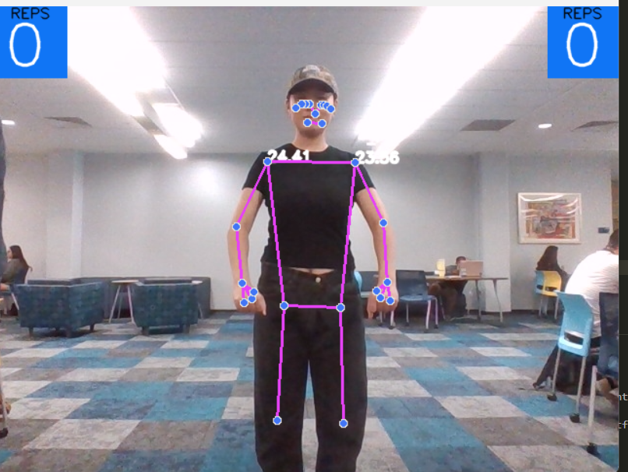 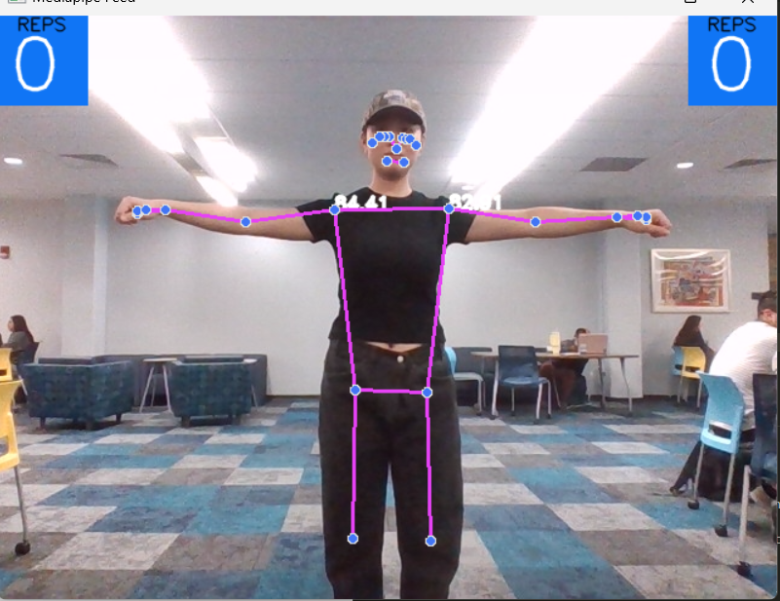

Triceps Extension

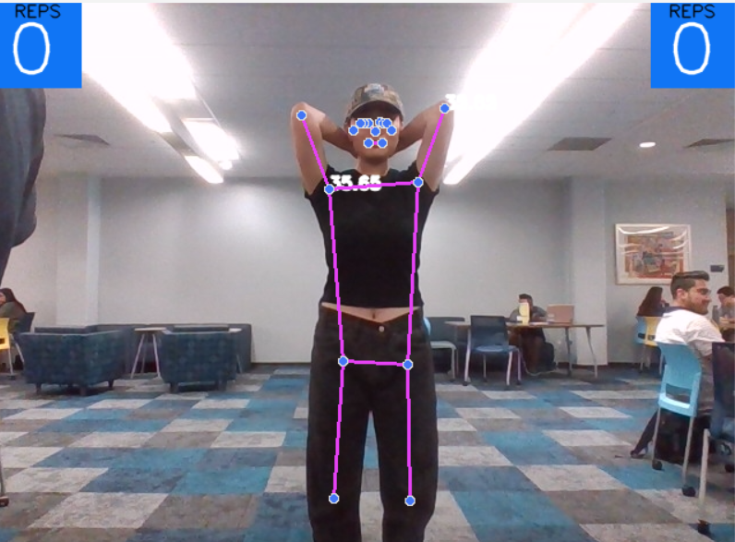 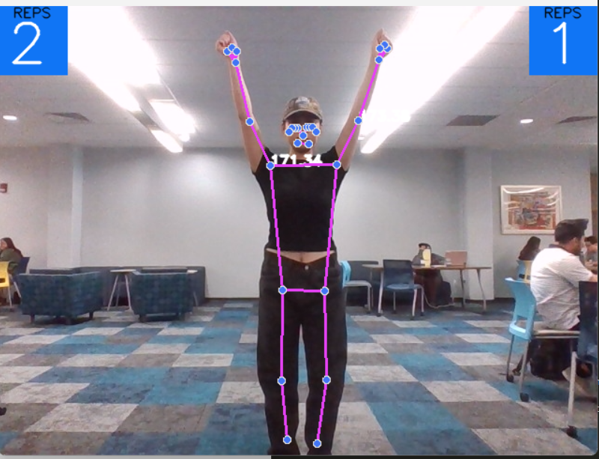

**Legs**

Squat

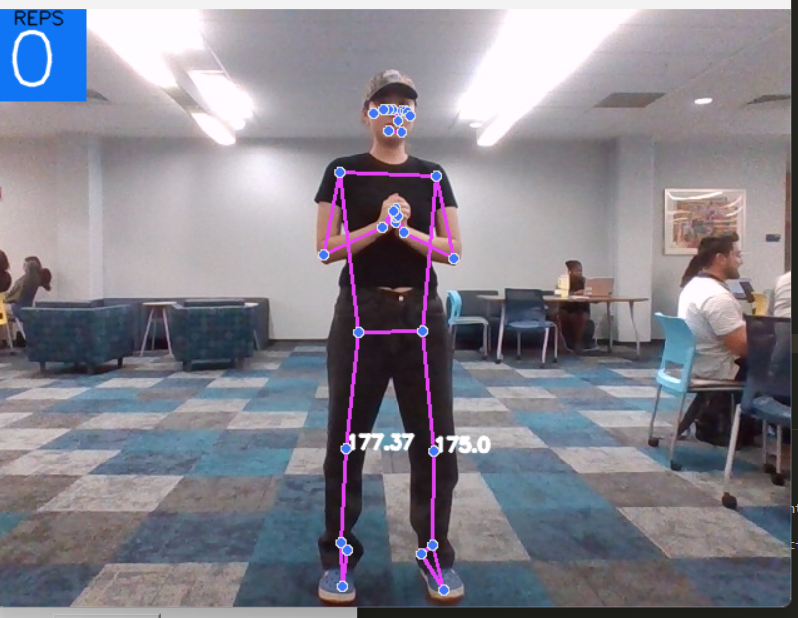 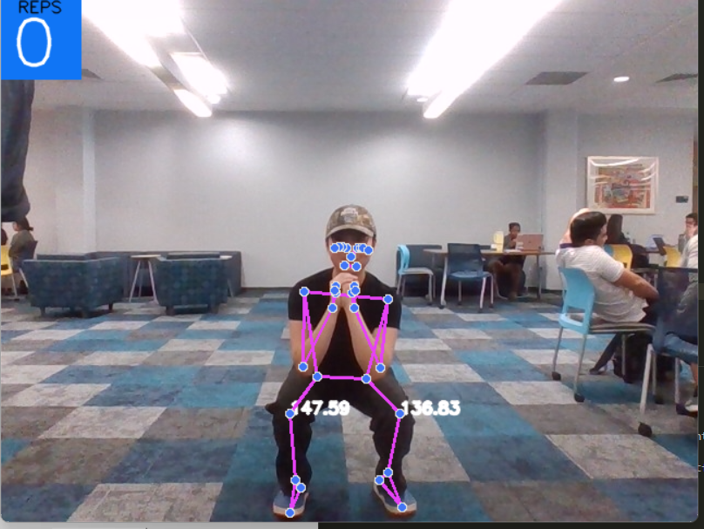

Leg Extension

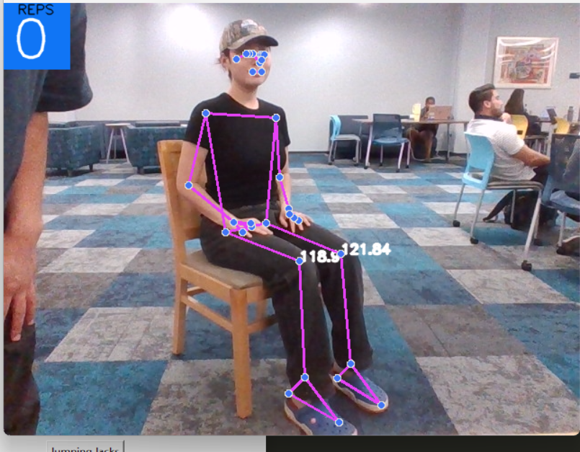 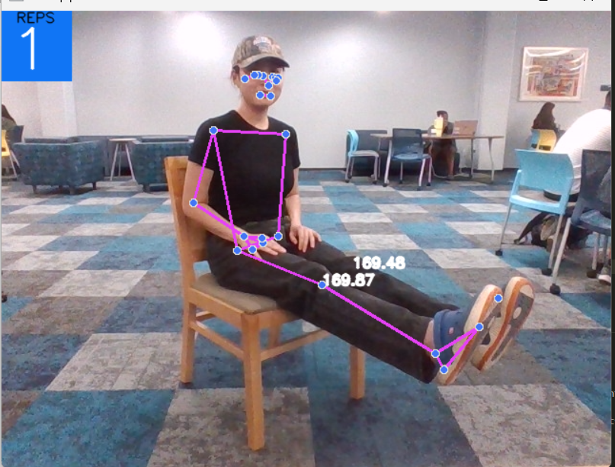

**Cardio**

Jumping Jacks

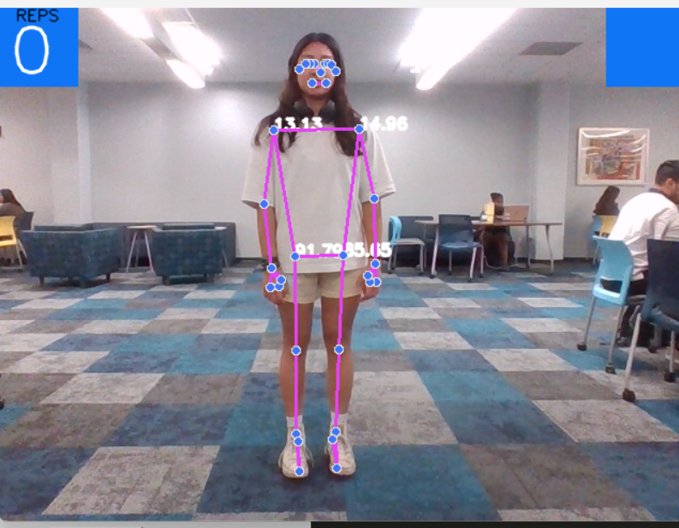 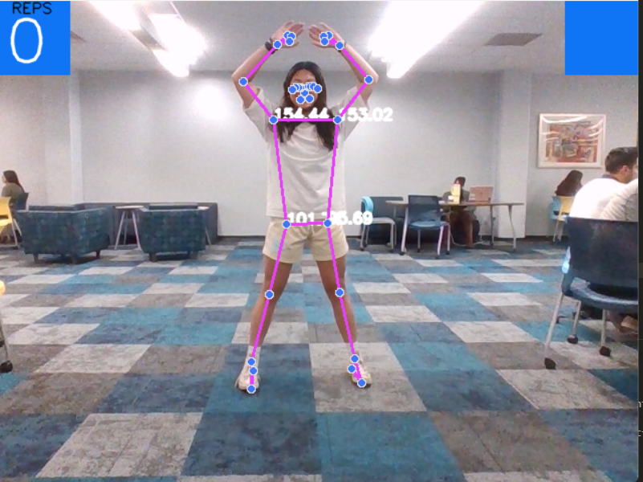

High Knees

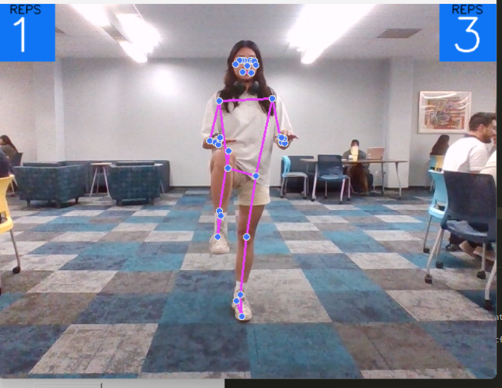 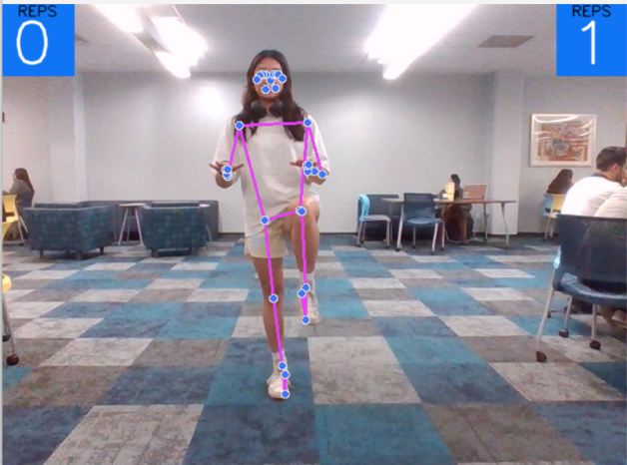

The GUI has the option to do full workouts.







When choosing these options, the program will give you a set of workouts to perform, respective of what muscle group you would like to work out.

For instance, choosing “Full Arm Workout” will cause the program to make you do Dumbbell Curls, Lateral Raises, and Triceps Extensions right after each other.

Adjusting parameters will allow you to choose how many reps you want the program to stop at. For the sake of timing for demonstration, the attached Python program makes the user perform five reps of each workout.